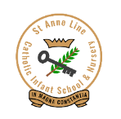

**St. Anne Line Catholic Infant School & Nursery**  **Medical Administration Form**

**St Anne Line Infant School & Nursery will not give your child medicine unless you complete and sign this form.**

|  |  |  |  |  |
| --- | --- | --- | --- | --- |
| **Name of Child:** | |  | | |
| **Date of Birth:** | |  | | |
| **Class Teacher:** | |  | | |
| **Medical Condition / illness:** | |  | | |
| **Name / Type of medication:** | |  | | |
| **Date treatment started:** |  |  | | **Expiry Date:** |
| **Dosage, method and timing:** | |  | | |
| **Are there any side effects that the school / setting needs to know about?** | | | | |
| **Storage / additional instructions:** | | | | |
| **Emergency contact Name & Number:** | | | **Relationship to child:** | |

**I understand that I must deliver the medicine personally to the School Office and collect any remaining medication when the course is completed. I accept that the school has the right to refuse to administer medication.**

**Name: ………………………………………………………………. Relationship to child: …………………………………………**

**Signed: ……………………………………………………………... Date: …………………………………………………………………**

**STAFF INDEMNITY**

**Essex County Council fully indemnifies its staff against claims for alleged negligence, providing they are acting within the scope of their employment, have been suitably trained and are following the LEA’s guidelines. For the purposes of indemnity, the administration of medicine falls within this definition and hence the staff can be assured about the protection their employer provides. The indemnity would cover the consequences that might arise where an incorrect dose is inadvertently given or where the administration is overlooked.**

**AGREEMENT AND CONCLUSION**

**A copy of these notes will be held by the School and the parents. Any necessary revisions will be subject of further discussions between the School and the parents.**

**On a termly basis, any changes in routine will be noted and circulated.**

**AGREED AND SIGNED**

**Headteacher: …………………………………………………………………………………….. Date: …………………………………**

**Parent/Guardian: ………………………………………………………………………………. Date: …………………………………**



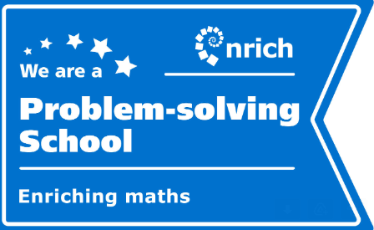   

Wickhay, Basildon,

SS15 5AF

Headteacher: Mrs. M. Clayton BA Hons

Telephone: 01268 524263

e-mail: [office@salinf.org](mailto:office@salinf.org)