Year 2 Dialogue and Encounter
Sticky Knowledge | Skills I need to use:
Dialogue  The parable of the Good Samaritan (Lk 10:25-37)  - Christians should join in service of humanity.  - Our local Christian community is Our Lady and All Saints, Basildon  - Our local Church is Holy Trinity.  - Our local Church holds a Polish Mass.  Encounter  - Recognise links and simple connections between some Jewish religious laws, beliefs, worship, and life.  - Recognise that most Jewish religious words are in Hebrew  - Listen to the religious experiences of others from different communities in the class and the local area. | Say what the story of the Good Samaritan teaches.    Describe a way Christians work together locally and globally in the service of others.  Make simple links and connections between some Jewish religious laws, beliefs, worship, and life  Talk about respecting the beliefs of people from different communities in their local area.    Consider ‘Who is my neighbour?’.  Explore some examples of Hebrew calligraphy by a sofer.  Listen to the stories of others from different communities and the wider community    Reflect on ‘Who is my neighbour?’ and wonder about how they can act as a good Samaritan.  Reflect on how communities could be transformed if people acted as good neighbours.
Vocabulary
Samaritan Sabbath Shabbat synagogue neighbour respect
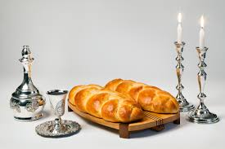
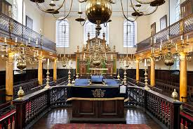
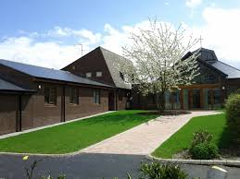

Holy Trinity synagogue Shabbat


