Year 1 Dialogue and Encounter
Sticky Knowledge | Skills I need to use:
Dialogue  - The Church is the community for those in God’s family.  - The cross is the symbol of Christianity  - Our school is in the parish of Our Lady and All Saints.  - Our local Church is Holy Trinity.  Encounter  - Jewish people believe in one God.  - The Torah is the special text.  - The Torah has stories of Jewish people’s life and helps guide Jewish people. | Know that Christian means follower of Jesus.    Recognise that Catholics are a part of a family, and all Christians are sisters and brothers.  Recognise simple connections between Jesus’ life and message and how Christians live today.  Recognise that the cross is a symbol of Christianity, and  the sign of the cross is a prayer expressing Christian  belief.  Use religious words and phrases to recognise features of  Jewish religious life and practice.    Listen to the stories and experiences of Christians from my local parish.  Talk about my personal response to artistic expression of Christian belief in a different Christian community.  Ask questions about the stories and experiences of Jewish people.    Consider how Christians in their local parish community could work together to help people.
Vocabulary
Christian Church parish community sign of the cross Jew Jewish/Judaism Torah
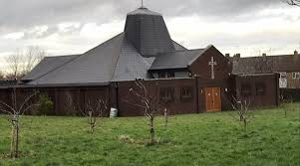
Holy Trinity Torah Cross


