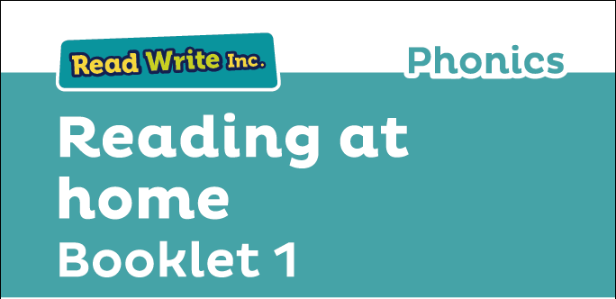

Glossary
Fred Talk – sounding out the word before reading (blending)

sound-blending – putting sounds together to make a word,
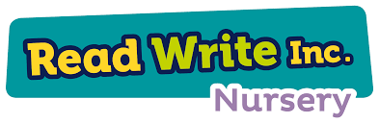
e.g. c–a–t cat

special friends – sounds written with more than one letter,
  - sh, ng, qu, ch

Speed Sounds – the individual sounds that make up words

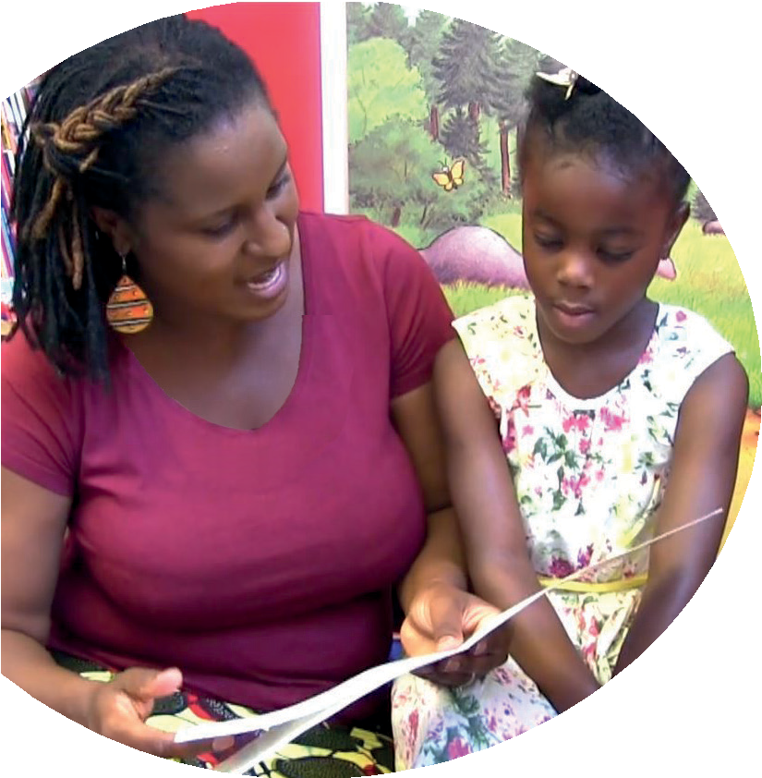
Read stories to your child with feeling! The more you love the story, the more your child will love reading.

Your child is beginning to learn to read with Read Write Inc. Phonics, a very popular and successful literacy programme we use at our school and nursery. This booklet shows you how you can get your child off to a quick start.
Your child will learn to read in a very simple way. He or she will learn to:
- Blend using Fred Talk with Fred Frog.
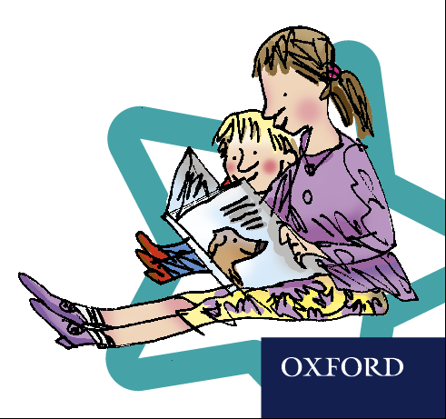
- Name the pictures of each sound.
- Read letters by their ‘sounds’
- Blend these sounds into words

www.ruthmiskin.com/parents has many videos to help you help your child.


For more information on Read Write Inc., please talk to the Read Write Inc. manager in your child’s school or visit www.readwriteinc.com.

8

1

Read stories to your child

How will my child learn to read in the nursery?
We have a storytime every day at school so children develop a love of stories. We
hope that you will do the same by reading a bedtime story to your child every night. We have wonderful books in school for you to borrow.

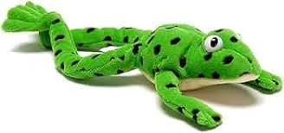
Please look at our reading spine on our website to see the quality books we use in nursery.

Songs and rhymes are wonderful to use at home to: https://www.bbc.co.uk/teach/school-radio/articles/z4ddgwx

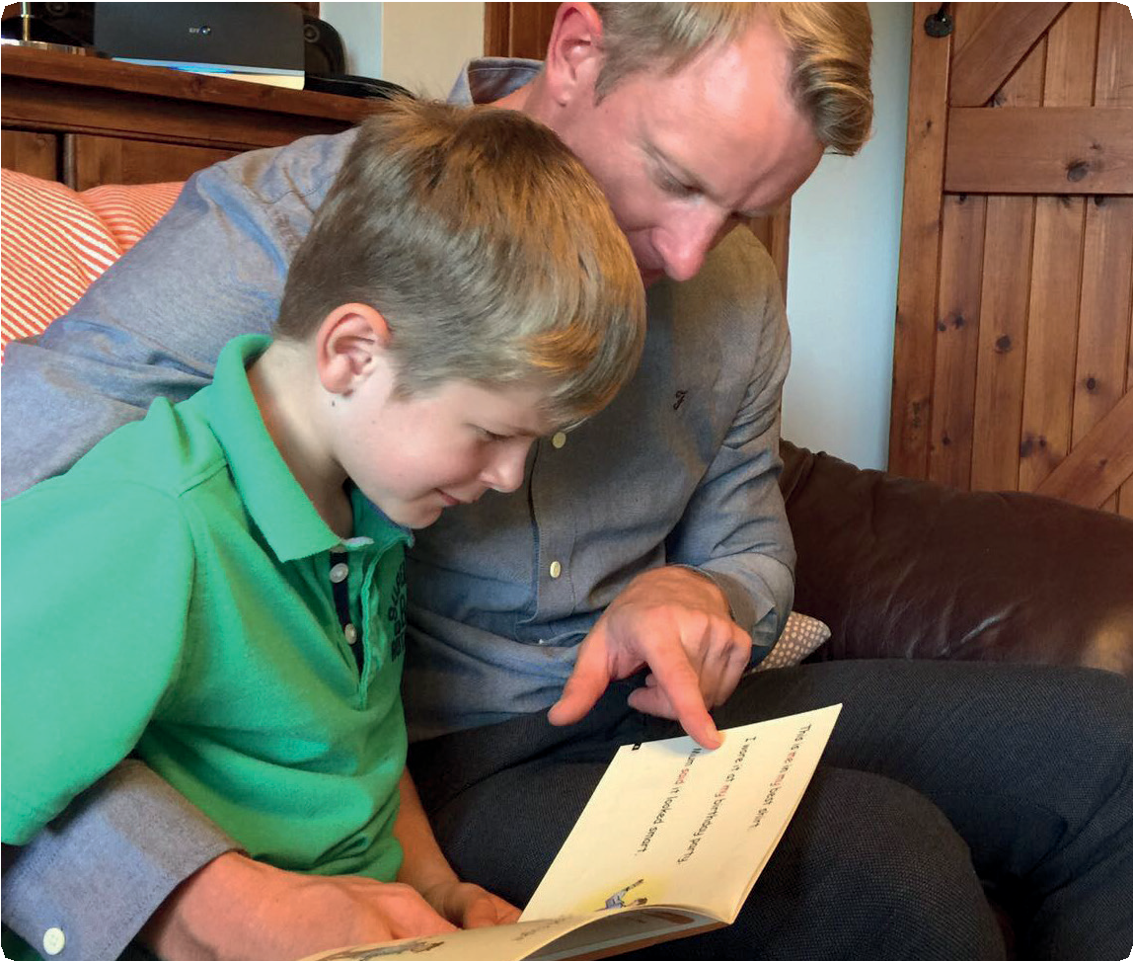

Children will be introduced to Fred Frog.

Fred Frog helps children to hear the sounds
in words and to blend the sounds together.

To help at home, use the QR code to play Fred Games:

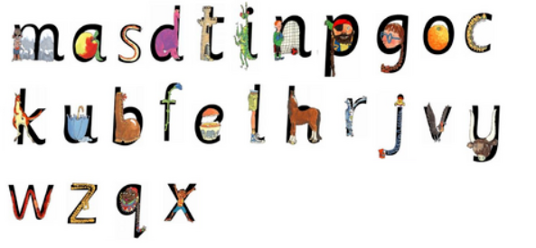


Children will learn the names of the pictures for each letter.
To help at home, watch the videos and help children to learn the picture names.

- m: Mountain
- a: Apple
- s: Snake
- d: Dinosaur
- p: Pirate
- t: Tower
- i: Insect
- n: Net
- g: Girl
- o: Orange
- c/k: Coat/Kite
- u: Umbrella
- b: Boot
- f: Flower
- e: Egg
- l: Leg
- h: Horse
- r: Robot
- j: Jack-in-the-box
- v: Vulture
- y: Yak
- w: Worm
- z: Zip

Next, your child will learn to read:
- Set 1 Speed Sounds: these are sounds written with one letter:
m a s d t i n p g o c k u b f e l h r j v
y w z x and begin to hear words containing these sounds, by sound-blending,
e.g. m–a–t mat, c–a–t cat, g–o–t got, f–i–sh ﬁsh,
s–p–o–t spot, b–e–s–t best, s–p–l–a–sh splash

Your child will be taught to say the sound for the letter and not the letter name, so ‘m’ as in ‘mat’, not ‘em’;
‘s’ as in ‘sun’ not ‘es’.



