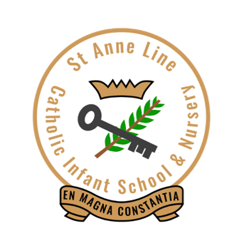

St Anne Line Catholic Infant School & Nursery Governing Body

Governing Body Membership Information

Category/Name | PO  (Years) | Start Date | End Date | Power | Appointing Body | Role/ Responsibility
Foundation Governors
Fr Albert Kollemkudy Chakkoo | 0 |  |  | Voting | Brentwood Diocesan Authority | Religious Education
Mrs Sarah Starling | 4 | 28.11.22 | 27.11.26 | Voting | Governing Body | Chair  Finance Committee  SEND  Standards  Data  Curriculum  HTPM Review  Leadership & Governance
Mr Paul Norris | 4 | 11.11.21 | 10.11.25  (Waiting confirmation from Diocese reappointment) | Voting | Governing Body | Vice Chair  Finance Committee  Safeguarding  Attendance & Behaviour  LAC  Standards  Data  Curriculum  HTPM Review
Mrs Alexandra Iguh-Ofoma | 0 |  | (Waiting for forms to be returned from Alexandra. | Voting | Governing Body | Personal Development  Standards  Data  Curriculum
LA Governor
 |  |  |  | Voting | LA
Staff Governors
Melanie Clayton | 0 | 01.01.23 | Ex officio | Voting | School Staff | Headteacher  Finance Committee
Mrs Claire Warren | 0 | 01.12.25 | 31.11.29 | Voting | School Staff | Deputy Headteacher  Finance Committee
Associate Governors
None Appointed
Parent Governor
Mrs Melissa Dube | 4 | 08.11.23 | 08.11.27 | Voting | Governing Body | Equalities

PO is the period of office which represents the number of years a person is appointed for.
Where the PO is zero this means a person serves until they leave the office, such as a Headteacher.

Historic Members (left within last 12 months)

Lynnette Braithwaite
Ma Celeste
Jean Baxter
Fr Saji Thomas

